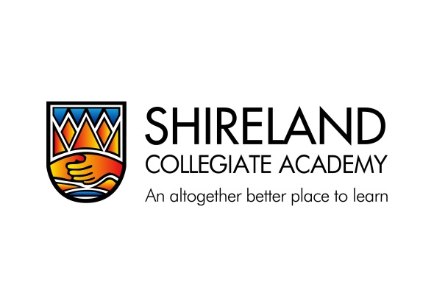

Arts Aptitude Application Form
Year 7 September 2024
Please complete this form in BLACK INK using BLOCK CAPITALS and return to: Admissions Office, Shireland Collegiate Academy, Waterloo Road, Smethwick B66 4ND by Friday 29 September 2023. You may alternatively e-mail the form to: sheila.riley@collegiateacademy.org.uk

Please put 1 in the box next to your first choice and 2 in the box next to your second choice
ART
DANCE
DRAMA
MUSIC

PERSONAL DETAILS OF CHILD
Surname: ………………………………………………………………… As registered with the Local Authority

First Name: ………………………………………………….............

Male or Female: ……………………………………………………..

Date of Birth: ...…………………………………………………..

Primary School: ……………………………………………………..

PARENT(S)/CARER (S) INFORMATION

Title Mr & Mrs/Mr/Mrs/Miss/Ms (delete as applicable)

Surname: ………………………………….................................

Home Address: ………………………………………………………… If this is not the address where
the child normally resides then
………………………………………………………………………………… please give further details on a
separate sheet
…………………………………………………………………………………

Postcode: …………........................................................

Contact Telephone No: ...............................................
Email : ……………………………………………………………………
Signed: …………………………………………………………………… Date: …………………………….

Print Name: …………………………………………………………… Parent/Guardian

